AGAINST ALL ODDS.
This prem pup has miraculously survived after being born a considerable time before due date.
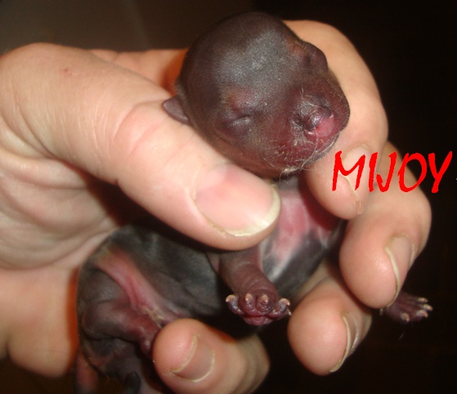

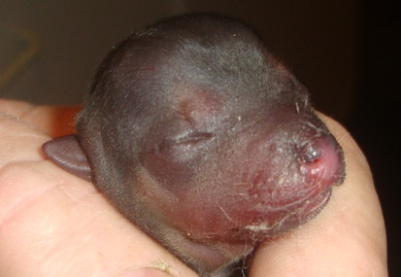

The pic below taken the day he was supposed to be born.
A very different looking baby.
